# GST 102: Spatial Analysis

## Lab 3 - Advanced Attributes and Spatial Queries for Data Exploration

### Objective – Understanding Attribute Queries and Spatial Queries

Document Version: 4/8/2015

**FOSS4G Lab Author:** Kurt Menke, GISP Bird's Eye View GIS

**Original Lab Content Author:** Richard Smith, Ph.D., GISP Texas A&M University - Corpus Christi

The development of the original document was funded by the Department of Labor (DOL) Trade Adjustment Assistance Community College and Career Training (TAACCCT) Grant No. TC-22525-11-60-A-48; The National Information Security, Geospatial Technologies Consortium (NISGTC) is an entity of Collin College of Texas, Bellevue College of Washington, Bunker Hill Community College of Massachusetts, Del Mar College of Texas, Moraine Valley Community College of Illinois, Rio Salado College of Arizona, and Salt Lake Community College of Utah. This work is licensed under the Creative Commons Attribution 3.0 Unported License. To view a copy of this license, visit http://creativecommons.org/licenses/by/3.0/ or send a letter to Creative Commons, 444 Castro Street, Suite 900, Mountain View, California, 94041, USA.

This document continues to be modified and improved by generous public contributions.

### 1. Introduction

In this lab students will explore data and decipher the data fields using a data dictionary table. The students will then perform queries on Census data using QGIS Desktop. The students will also create a buffer and learn the importance of buffering in combination with spatial queries.

This lab includes the following tasks:

* Task 1 – Using Data Dictionaries and Attribute Selections
* Task 2 – Buffering and Spatial Queries

### 2 Objective: Understanding Attribute Queries and Spatial Queries

The objective of this exercise is to learn how to query attribute data and how to derive information from attribute data. You will learn how to perform both attribute queries and spatial queries.

### Task 1 - Using Data Dictionaries and Attribute Selections

Data dictionaries (a.k.a., look-up tables) are usually in an electronic format. They are often included with datasets so that we can understand the type of data stored in a given field. They become necessary because with some geospatial data formats (shapefile, for example) attribute column names can be restricted to a small number of characters. For example, column names in a shapefile are limited to 10 characters. Therefore, data creators often resort to using codes as field names. Often the only way to know what type of data is stored in a given field is to review the data dictionary (example shown figure below).

In this task, we will look at the data dictionary given to us with some census data for the lower 48 U.S. states. The census data captures many attributes about the U.S population from the 2010 Census. These attributes contain a lot of useful information. The ability to query the data allows us to expose trends in the data.

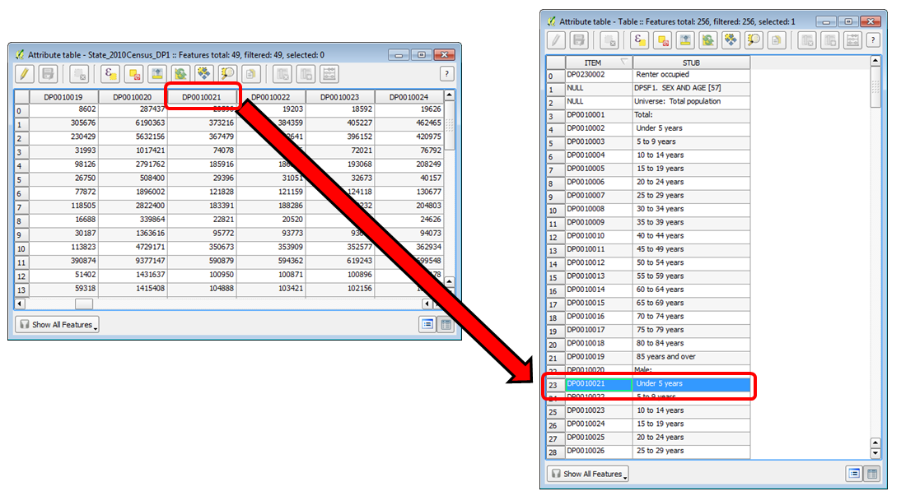

Attribute Table and Data Dictionary

#### Task 1.1 - Using a Data Dictionary

1. Open QGIS Desktop.
2. Click on the Browser tab. If the Browser tab is not enabled from the menu bar choose View | Panels | Browser.
3. Browse to the Lab 3 Data folder, right click on the Data folder and choose Add as a Favourite.
4. Expand the Favourites section at the top of the tree in the Browser panel and browse to Lab 3/Data/Census folder (shown in the figure below).

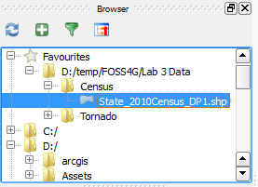

Data as a Favourite

1. Select the State_2010Census_DP1 layer and drag it onto the map canvas to add it to QGIS Desktop.
2. Now you will set the coordinate reference system for the map. From the menu bar go to Project | Project Properties.
3. Enable ‘on the fly’ CRS transformation and put the map into NAD83/Conus Albers (EPSG:5070).
4. Save the project as Lab 3 Census.qgs in your lab folder.
5. Open the attribute table for the State_2010_DP1 layer.

There are a lot of attribute columns. It is clear that a naming convention has been used, but there is no way to understand what data in contained in each field by the field names alone.

1. Close the attribute table.
2. The data dictionary is located in DP_TableDescriptions.xls. Click the Add vector data button and browse to the Lab 3/Data/Census folder. If you don’t see the spreadsheet, change the file filter in the lower right corner to All files (*)(*.*). Select the spreadsheet and click Open (shown in figure below).

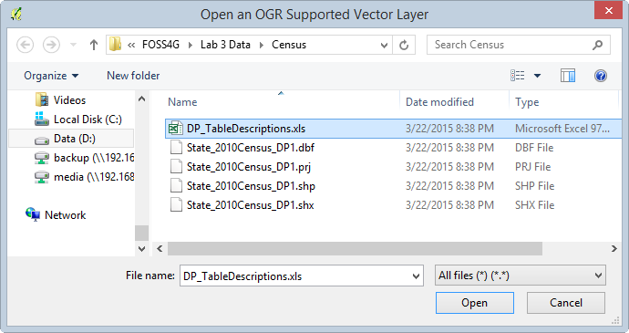

Adding the Data Dictionary Spreadsheet to QGIS Desktop

We will map the male population under age 5 for the lower 48. To determine which field in the state census shapefile contains that data, we need to consult the data dictionary table.

1. Right-click on Table in the Layers panel and choose Open attribute table from the context menu.

The data dictionary table has two columns: Item and Stub. Item contains the field names stored in the shapefile. Stub is a short description of the values stored in the field. Scroll down to see that the male under 5 years data is contained in the DP0010021 field. Now that we know which field has the data we are interested in mapping, we can get to work.

1. Close the attribute table.
2. We will now style the layer using the under 5 years values. Open the Layer Properties of the State_2010Census_DP1 layer and go to the Style tab.
3. Use the criteria below. When finished your map should resemble figure below.
   * Choose a Graduated renderer.
   * Column = DP0010021
   * Mode = Quantile (Equal count)
   * Classes = 5
   * Color ramp = Blues

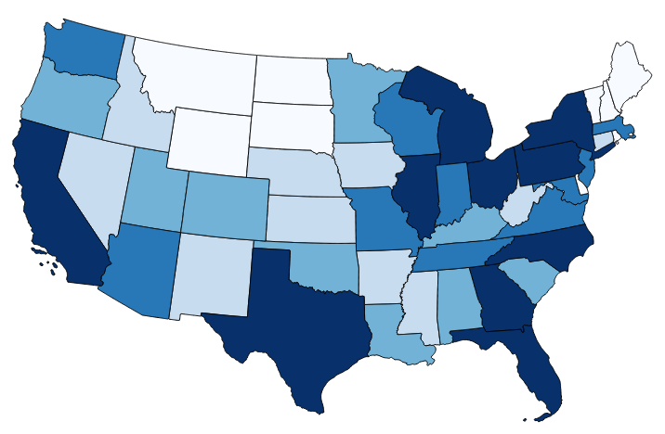

Under Age 5 Population of the Lower 48

1. Save your map. You will be using this QGIS Desktop project in task 1.2

#### Task 1.2 - Attribute Selections

Using the map you have just created in Task 1.1, you will now perform some queries against the census data.

1. If you do not have it open, open the Lab 3 Census.qgs project created in Task 1.1.
2. Open the attribute table for the Census layer.
3. Click the Select features using an expression button expression button . The Select by Expression window opens.
4. You have mapped the states by the under 5 male population. Now you want to know which states have a total population less than 1,000,000. The figure below shows the layout of the Select by Expression window.
   * Fields and Values are included in the list of functions. You can expand the list to see the fields in the dataset.
   * There are a suite of operators to use in building your expression.
   * The expression window. Double-clicking on Fields, Values and Operators will place those objects in the expression window. It is best to build your expression this way instead of trying to type it. This will allow you to avoid syntax errors.
   * Select options: By default, you will create a new selection. However, you can choose to add to an already existing selection, have records removed from an existing selection, or select from an existing selected set.

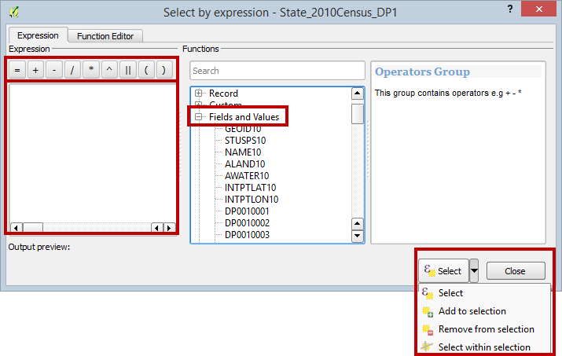

Select by Expression Window

1. First, you will have to refer to the data dictionary to see which field contains the total population values. To select those states with a total population less than 1,000,000 you will:
   1. Double click on field DP0010001
   2. Expand the Operators in the Function list and choose ‘<’
   3. Type in the value of 1000000. *Note*: Since you want a specific numeric value, you will type it in here. You could choose the DP0010001 field and then click on Load values: all unique and see if there is a value of exactly 1000000. However, it is unlikely that you will find a precise even value like that. In these cases, type the value in without thousand separator commas. Also note that numeric values do not receive quotes (“) or tics (‘).
2. If your expression looks like the figure below. Click Select to perform the selection then close the Select by expression window.

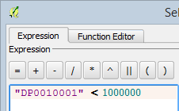

Population Select by Expression Window

1. The selected records are highlighted in blue in the attribute table.
2. Click the Show All Features dropdown (bottom-left corner of attribute table window) and choose Show Selected Records. Now you are viewing only the 7 selected records.
3. Click on the DP0010001 header to sort the selected records by total population. Now you can easily see which state has the highest and which has the lowest population among the seven selected (shown in figure below).

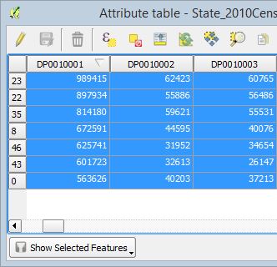

Seven Selected Records Sorted by Total Population

1. Close the attribute table.
2. The corresponding features are selected in the map as well. Your map should now resemble the figure below.

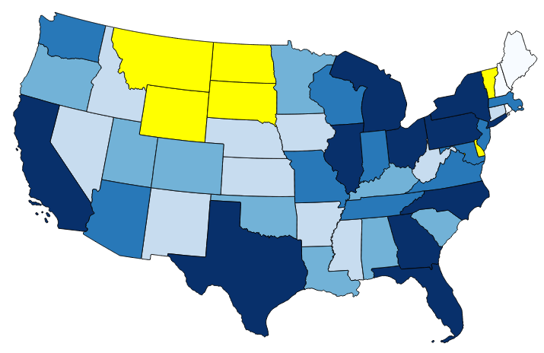

States With a Total Population Less Than 1,000,000 Selected

1. Re-open the attribute table and create an expression selecting the states with a total population greater than 10,000,000. Your map should now match the figure below with seven selected states.

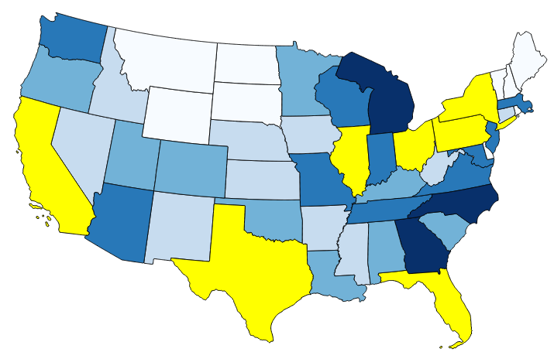

States With a Total Population Greater than 10,000,000 Selected

### Task 2 - Buffering and Spatial Queries

Buffering is a key vector analysis tool in GIS. It gives us the ability to create a new GIS layer representing a buffer distance from some map feature(s).

#### Task 2.1 - Running the Buffer Tool

1. Open QGIS Desktop and open Lab 3 Data/Tornado/Tornado.qgs.
2. The redline represents a tornados path through a residential area. The approximate area of damage was 900 meters around the path. The green polygons represent schools in the area, the parcels are in yellow and the roads black lines.

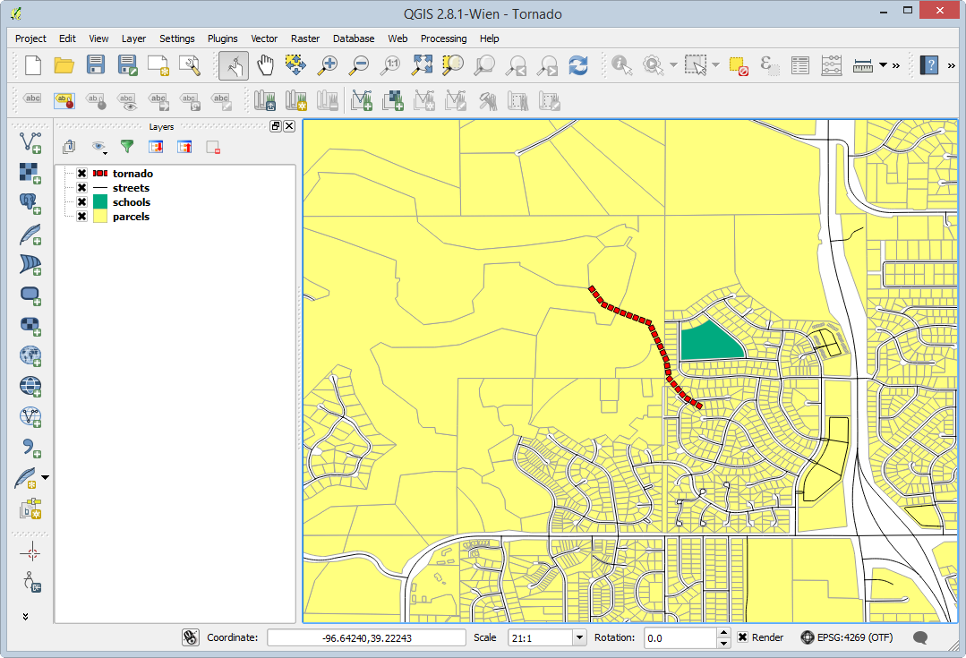

Tornado Path QGIS Project

To identify the area impacted by the tornado, you will create a 900 meter buffer around the path.

1. From the menu bar choose Vector | Geoprocessing Tools | Buffer(s). Fill out the Buffer tool with the parameters seen in the figure below.

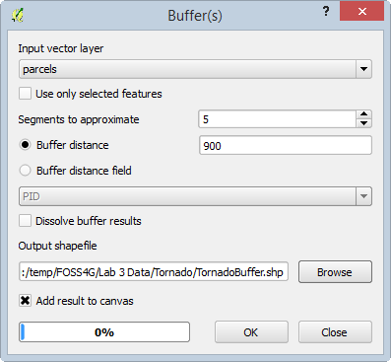

Tornado Path QGIS Project 2

1. Click OK to run the tool, and click Close when it has finished.

A new polygon layer is created that covers all the land 900 meters from the tornados path. You will need to make the new layer semi-transparent so that you can see what parcels, schools, and roads were affected.

1. Open the Layer Properties for the buffer layer and choose the Style tab. Set the Layer transparency to 50% (shown in figure below).

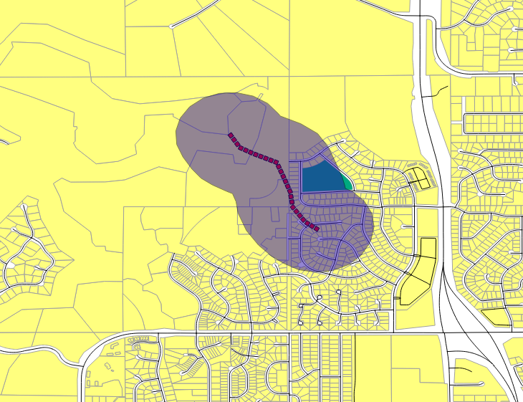

Tornado Buffer

Looking at the result we can immediately see the areas affected by the tornado.

1. Save the QGIS project.

#### Task 2.2 Performing Spatial Queries

In this task, you will learn how to identify exactly which parcels were affected by the tornado.

1. Begin with the QGIS Desktop map as you saved it at the conclusion of the previous task.
2. From the menu bar choose Vector | Research Tools | Select by location.

Using select by location, you can conduct spatial queries. In this case, we can determine which parcels overlap with the tornado buffer.

1. Fill out the Select by location form as in the figure below. Click OK to perform the buffer, then click Close.

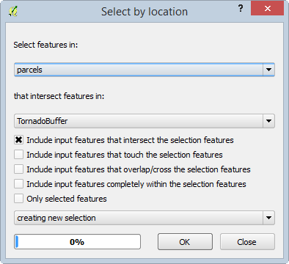

Select by Location

1. The parcels that intersect the tornado buffer are now selected. However, the default yellow selection color is very close to the yellow color of the parcels. To change the selection color go to the menu bar choose Project | Project Properties and click on the General tab.
2. Change the Selection color to a blue color so the selected parcels stand out better (shown in figure below).

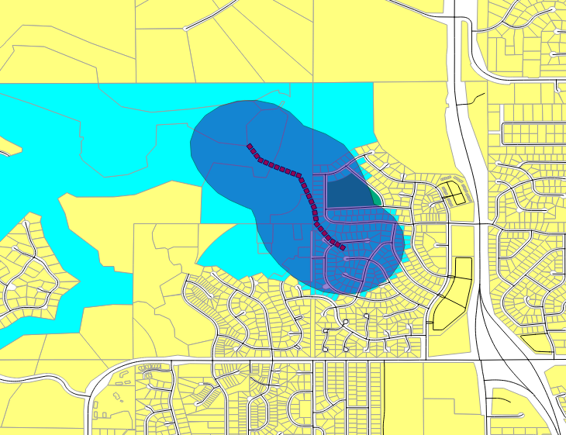

Affected Parcels Selected

From here, you could save out the selected parcels as a new shapefile. To do this you would right-click on the parcel layer and choose Save As… then check Save only selected features. You could also open the parcel attribute table and Show Selected Features to examine the attributes of those affected parcels.

1. Finally you will examine the total value of the affected parcels. From the menu bar choose Vector | Analysis Tools | Basic Statistics.
   1. Select parcels as the Input Vector Layer.
   2. Check Use only selected features.
   3. Set the Target Field to TOTALVAL
   4. Click OK

The results are shown in the figure below. Now you know the total value of the affected parcels! This is a great example of how you can generate information from GIS data.

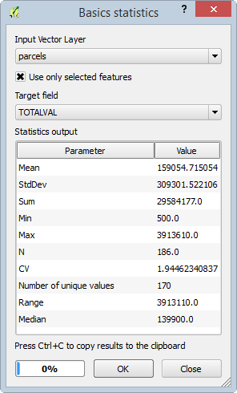

Statistics on the Total Value of the Affected Parcels

### 3 Conclusion

In this lab, you explored the use of data dictionaries with coded field names. You experienced another example of using attribute table queries. You used a buffer operation combined with the select by location operation and basic statistics tools to determine to total value of parcels impacted by a tornado.

### 4 Discussion Questions

1. Why do we need data dictionaries?
2. How are Attribute selections useful in a GIS?
3. Why are buffering and spatial selections important to us?

### 5 Challenge Assignment (optional)

Repeat the steps in the second task to determine the roads that were impacted by the tornado. Report the affected road names to your instructor. Make a map composition of both the impacted roads and parcels. Turn in the final map to your instructor.